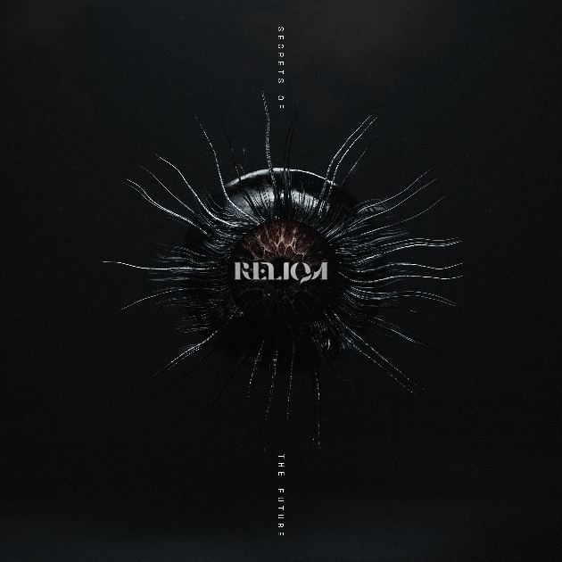

RELIQA
Secrets Of The Future

Release Date: May, 31st 2024

Line up: | RELIQA online:
Monique Pym – Vocals  Brandon Hutcheson – Guitar  Miles Knox – Bass  Benjamin Knox – Drums | instagram.com/reliqaband  twitter.com/reliqaband  facebook.com/reliqaband
The journey is always as important as the destination. It could be even more important. It's a mantra that many of us should be reminded of. Simply because you need to take stock of how you have got from A to B to grow. How can you face a world that is forever changing around you if you don't adapt and learn from the motion? You only get to do this life once, so you better embrace every step that you take. Otherwise, you're going to regret it.

This is something that RELIQA have mastered throughout their adventure so far. Rising from the Sydney underground, they have become one of Australia's most exciting new prospects, supporting everyone from Make Them Suffer and Spiritbox to Void Of Vision and BABYMETAL. With every new experience, they have endeavored to bottle everything they felt and feed off it as much as possible as they look to the next milestone. Remembering exactly how it felt to watch their dreams playing out before them and using it as a light as they venture into the unknown.

Those lessons learnt and that life lived find their way into their debut full-length album Secrets Of The Future. An album that speaks to where you have been and looks forward to where you are heading, it is the sound of a band leaving no stone unturned in their pursuit of complete musical expression. Taking the most savage and passionate elements that make modern metalcore such an institution, then throwing lashings of electronica, pop, prog and post-hardcore in for the thrill of it, the result is ferocious, forward-thinking and, most importantly, fun.

"There's a vibrance and excitement that I think a lot of people feel doesn't belong in metalcore spaces, or even in heavy spaces, to be honest,” vocalist Monique Pym explains. "But, like, it absolutely does. These shows, events, and cultural phenomena that we're a part of are fun. This is supposed to be fun. We're still young in the grand scheme of things, and we still feel like those kids practicing in the garage when we were 16. So, that's a feeling that we will keep trying to hit."

In many ways, Secrets Of The Future is an incredibly meta look at what it has meant for RELIQA to find their footing as artists. Working alongside producer Chris Blancato, the band strived to build the songs they were writing up less piece by piece and more as a whole entity. Putting pen to paper with intention and knowing precisely what it is they are working towards. Approaching how the band functions allowed them to be more honest with each other about why they are doing this in the first place and what they want to achieve. The things that have propelled them up to now and the things they hope they can stand for in the coming years. An intentional shift into doing things differently.

The result is a collection of musings on the empathy, understanding, frustration and conflict that come with trying to live out your dreams. Of the things you have to consider if you want your art to become a part of the universal consciousness and the pressure that comes with that. The fear of not reaching your potential, the anxiety of putting a foot wrong and the doubt over whether you're going in the right direction. It all plays a part. That's where the title comes from; the literal sense of trying to unlock a potential that you pray is there.

"There's so much excitement around what we are doing, but there is also so much pressure put on artists to deliver," Monique admits. "With our music, we are actively trying to work out the literal secrets of the future of all this. The secrets of our own future as well. We are sitting here like puzzle solvers, trying to crack the code of life. But then, what do you do when you have such terror about what that future might look like?"

Well, in the case of RELIQA, you throw everything you have into the mix. You create a smorgasbord of inspiration and devour every crumb that you can. 'Killstar (The Cold World)' rallies with technical pummeling and expansive world-building, 'Sariah' provides balladry of the most beautifully feminine variety and 'Terminal' smashes together thunderous techno and neon-drenched riffing like it is second nature. This no-holds-barred approach to creativity, matched with a vulnerability on what it means to tailor your whole life towards your art, makes for a sensationally human listen. One that puts you front and centre to how it feels to strive towards your destiny with equal parts triumph and trepidation under your wings. The world around us may be mostly a scary unknown, but you can create a universe for yourself where that apprehension is a motivating factor.

"There is an eagerness to how we have done things," Monique builds. “The love, admiration and respect we have for each other and the band, has allowed us to create something that sits on the more positive side of the spectrum. Of course, there's a polarity to it because the light cannot exist without the dark, but it was comforting to approach all of these differing emotions and put them on a page. These fleeting moments of the human experience have so much vibrance and fun behind them. That's what has excited us the most."

However, what stands tall above everything else on Secrets Of The Future is the fact that RELIQA know exactly who they are in the present. Exuding the sort of confidence and courage that some bands never truly harness and placing themselves at the forefront of what is thrilling about heavy music in 2024. Through vigorous experimentation and unwavering enthusiasm, they represent the beginning of the new wave. Possessing a fresh and honest perspective on the world around them and not letting anything stand in their way, this chapter feels like the beginning of something truly extraordinary.

"The music industry is a conversation," Monique smiles. "And I like that we can do everything possible to keep that conversation alive. We've worked hard and learned a lot throughout making this album. And I feel that that learning will not go to waste. We're standing on the precipice of what is still to come. We may not be in control of every step we have to take, but we do get to control how we respond to it. We're looking up to our elders and those who came before us while also being excited to usher in the new generation following us. It's open, it's welcoming, and it's truly a privilege."

